<-----------------Algo starts--------------------------->
/*Function to print level order traversal of tree*/
/*
printLevelorder(tree)
for d = 1 to height(tree)
printGivenLevel(tree, d);
/*Function to print all nodes at a given level*/
/*printGivenLevel(tree, level)
if tree is NULL then return;
if level is 1, then
print(tree->data);
else if level greater than 1, then
printGivenLevel(tree->left, level-1);
printGivenLevel(tree->right, level-1);
*//*
<-----------------Algo ends--------------------------->
*/
1)After tree is created on last line of psvm tree.printLevelOrder();//12345(bfs)
the value of root which ius an instance of Node and has been connected to BinaryTree class via constructor will contain the entire tree

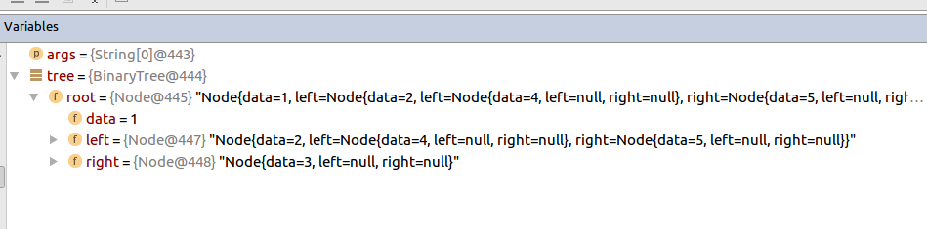
2)Now height will be calculated via recursion . In all recusrsion there is a winmding condition where all recursion end up which is also here
if (root == null)
return 0;
3)When it enters height
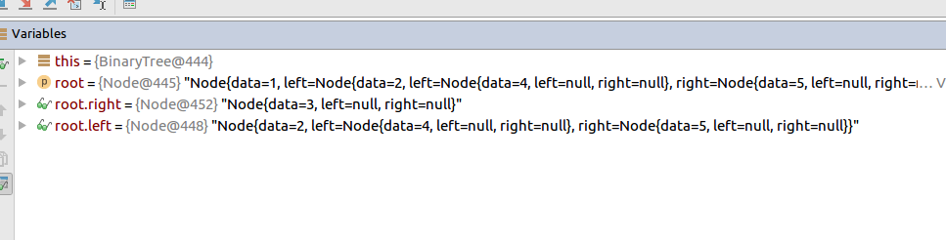
the root.left and root.right divides themselves into left and right sub tree

4)The same function will recurse with left subtree till root becomes null
int lheight = height(root.left);
The fist time lheight and rheight will be 0 after recursion will be 0

